# Exercise: Objects and JSON

Problems for in-class lab for the [“Technology Fundamentals” course @ SoftUni](https://softuni.bg/trainings/2056/technology-fundamental-september-2018#lesson-9616).

Submit your solutions in the SoftUni judge system at: [Objects-and-JSON-Lab](https://judge.softuni.bg/Contests/1323/Objects-and-JSON-Lab)

## Person Info

* Write a function that receives **3 parameters** sets them to an object and prints the object's entries.
* The input comes as **3 separate strings** in the following order: firstName, lastName, age.

### Examples

|  |  |
| --- | --- |
| **Input** | **Output** |
| "Peter", "Pan", "20" | firstName: Peter  lastName: Pan  age: 20 |

### Hints

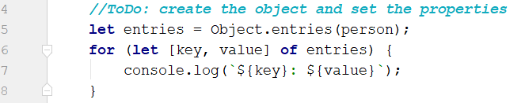

## City

* Receive **five single strings**.
* Create a **city object** which will hold the city name, area, population, country and postcode.
* Loop through all the keys and print them with their values
* The input will be in the following order: name, area, population, country and postCode.

### Examples

|  |  |
| --- | --- |
| **Input** | **Output** |
| "Sofia"," 492", "1238438", "Bulgaria", "1000" | name -> Sofia  area -> 492  population -> 1238438  country -> Bulgaria  postCode -> 1000 |

## Convert to Object

* Write a function that receives a **string** in **JSON format** and converts it to object.
* Loop through all the keys and print them with their values

### Examples

|  |  |
| --- | --- |
| **Input** | **Output** |
| '{"name": "George", "age": 40, "town": "Sofia"}' | name: George  age: 40  town: Sofia |

### Hints

* Use JSON.parse() method to parse JSON string to an object

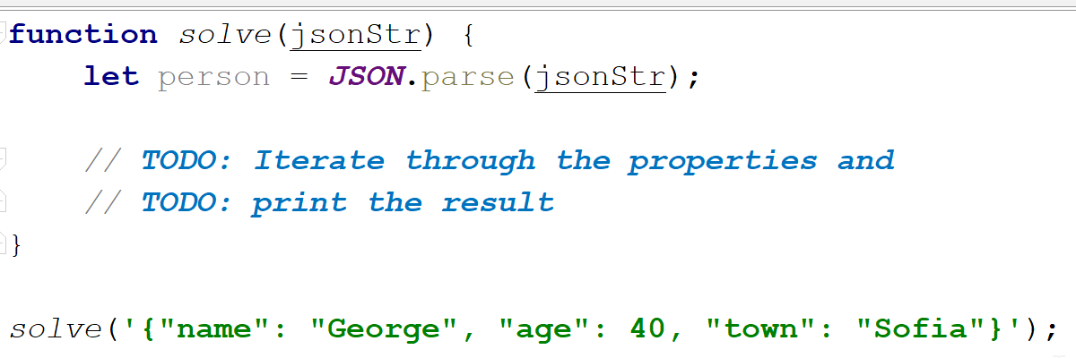

## Convert to JSON

### Write a function that receives name, last name, hair color and sets them to an object.

* Convert the **object** to **JSON string** and print it.
* Input is provided as **3 single strings** in the order stated above.

### Examples

|  |  |
| --- | --- |
| **Input** | **Output** |
| 'George',  'Jones',  'Brown' | {"name":"George", "lastName":"Jones", "hairColor":"Brown"} |

### Hints

* Use **JSON.stringify( )** to parse the object to JSON string

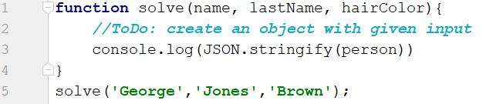

## Cats

* Write a function that receives array of strings in the following format **'{cat name} {age}'**.
* Create a Cat class that receives in the constructor the name and the age parsed from the input.
* It should also have a function named **"meow"** that will print **"{cat name}, age {age} says Meow"** on the console.
* For each of the strings provided you must **create a cat object.**

### Examples

|  |  |
| --- | --- |
| **Input** | **Output** |
| ['Mellow 2', 'Tom 5'] | Mellow, age 2 says Meow  Tom, age 5 says Meow |

### Hints

* Create a Cat class with properties and methods described above.
* Parse the input data
* Create all objects using class constructor and the parsed input data, store them in an array
* Loop through the array using **for…of** cycle and **invoke .meow()** method

